Synthesis and characterization studies of nickel oxide (NiO) nanoparticles

G. Padmapriya
¹ Department of Chemistry, Bharath Institute of Higher Education and Research,
Bharath University, Chennai – 600 073, Tamil Nadu, India

Abstract
Nanostructured nickel oxide (NiO) semiconductor materials were synthesized effectively by the novel microwave irradiation method using glycine as the fuel. The prepared NiO nanopowders were characterized by powder XRD, elemental composition analysis (EDX), FT-IR spectra, HR-SEM, and room temperature vibrating sample magnetometer (VSM) analysis. The powder XRD results were established the formation of single pure cubic phase NiO structure. The formation of NiO nanoparticle-like morphology was confirmed by HR-SEM analysis. The magnetic characterizations of NiO nanoparticles were investigated with VSM analysis and the observed magnetic hysteresis loop was confirmed the weak ferromagnetic nature of NiO sample. The saturation magnetization of the sample is 20.93 emu/g confirmed ferromagnetic behavior.

Keywords: Nickel oxide, Nanoparticles; Irradiation; Electron microscopy; Magnetic properties.

1. Introduction
Recently, semiconductor nanomaterials exhibit distinctive properties than that of their bulkiness materials [1]. Amongst them, metal oxide materials with nano-sized morphology have acknowledged great attention, due to their significance in materials science and nanotechnology [2]. However, nickel oxide (NiO) nanoparticles have mostly studied by many researchers, because of low cost and low toxicity in nature. Recently, nanosized NiO has potential applications in many fields, such as sensors, catalysts and solar cells. Also, NiO nanoparticles have been used extensively in opto-electomagnetic materials [3-5]. Moreover, NiO is a semiconductor material (p-type) with a wide energy band gap of 3.6 eV.
Several techniques such as sol-gel, hydrothermal, co-precipitation [6-8] methods, etc. have been used for the synthesis of metal oxide nanoparticles. Moreover, the above methods meet some disadvantageous such as higher energy overriding and necessitate slightly long reaction times to complete the products formation. Recently, microwave irradiation method has been used for the preparation of such functional metal oxide nanostructure. This method has more advantages such as high purity products than the above said conventional methods [9-16].
Hence, in the present work, we have reported NiO nanoparticles prepared by unique microwave irradiation method and investigated their structural, morphological and magnetic properties. The prepared NiO nanoparticles was characterized by powder XRD, EDX analysis, FT-IR analysis, HR-SEM and room temperature VSM analysis and the observed results are discussed in this article.

2. Experimental
2.1 Preparation of NiO nanoparticles by Microwave Irradiation Method
In this method nickel nitrate (Ni(NO₃)₃.6H₂O) act as oxidizing agent, whereas glycine act as a reducing agent as well as fuel. Stoichiometric amount of metal nitrate and glycine were dissolved individually in 20 ml of distilled water and taken in a alumina crucible and stirred for 15 minutes, and the placed in a microwave-oven for 10 minutes [9-15], the solution was vaporized and immediately became a solid. The solid powder was washed with ethanol and dried in an electric oven at 80°C for 2 h. This product was labeled as NiO.

2.2. Characterizations
The structural analysis was performed using a Philips X’pert X-ray diffractometer (λ = 1.540 Å). The formation of functional groups was analyzed by Perkin Elmer FT-IR spectra. Morphological analysisand elemental composition analysis have been performed with a Jeol JSM6360 HR-SEM. Saturation magnetization, remnant magnetization and coercivity were investigated using room temperature VSM measurement.

3. Results and discussion
3.1. Powder XRD analysis
The average crystallite size, structural and phase purity of NiO nanoparticles was analyzed by powder XRD pattern. Fig. 1 shows the powder XRD pattern of NiO sample. The XRD diffraction peaks at 2 θ values positioned at 37.35, 43.38, 62.93, 75.47, and 79.46º, matching to (111), (200), (220), (311) and (222) planes (JCPDS No. 78-0643), showed the formation of a single phase and pure cubic NiO, which confirmed that the microwave heating completely decomposed the precursors and produced NiO nanoparticles.
The average crystallite size of NiO nanoparticles was calculated using Debye Scherrer’s formula given in Eq. (1)
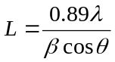 ---- (1)
where L is the crystallite size, θ, the Bragg diffraction angle, λ is the X-ray wavelength, and β is the full width at half maximum (FWHM). The average crystallite size is 17.15 nm.
The lattice parameter of NiO nanoparticles was calculated using the formula given in Eq. (2):
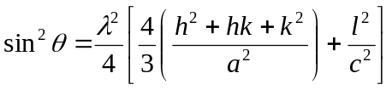 ---- (2)
where θ is the diffraction angle, h, k, and l are Miller’s indices and λ is the incident wavelength
(λ = 1.540 Å). The lattice parameter of NiO sample is found to be a = 5.012 Å and c= 13.695 Å, which are extremely close to the reported values (a = 5.033 Å and c = 13.753 Å, JCPDS No. 89-0598).

3.2. FT-IR Spectroscopy
Fig. 2 shows FT-IR spectra of NiO sample. A wide-ranging vibration band at ~3450 cm⁻¹ to 3250 cm⁻¹ is connected with the hydroxyl (OH) stretching vibrations of H₂O molecules, representing superior amount of surface OH, while those at ~1610 cm⁻¹ are related with their bending mode. The one is commonly observed in the range 850-450 cm⁻¹, and it match to stretching vibrations of the NiO sample.
3.3. SEM studies
The surface appearance or morphology surface of the powders was established by the HR-SEM analysis. Fig. 3 shows the HR-SEM image of NiO nanostructure. From the image, we can see the particle like morphology of the samples. Also, it was experimental that the presence of smaller agglomerated nano-crystals. Hence, we can assume that the NiO nano-crystals have been shaped during the microwave irradiation process.

3.4. EDX Analysis
The elemental analysis and purity of NiO nano-crystals was determined by EDX spectra as shown in Fig. 4. The EDX analysis showed the presence of Ni and O elements by the manifestation of Ni and O peaks with no any other impurity peaks. Hence, the microwave irradiation method reactions are authoritative evidence to propose that the sample NiO product only.

3.5. VSM Measurements
The magnetic properties (saturation magnetization, remnants magnetization and coercivity) and dia/para and ferromagnetic nature of the materials was confirmed by the VSM analysis [17-20]. Fig. 5 shows the room temperature VSM results for NiO nanoparticles in the magnetic field range from -10000 to +10000 Oe. It is well known that the nickel oxide (NiO) is very important semiconductor magnetic metal oxide, due to their potential applications in multidisciplinary areas. From the analysis, it was observed that lower values of coercivity (H_{c}), saturation magnetization (M_{s}) and remnant magnetization (M_{r}) of NiO sample. Also, we can propose that the NiO nanoparticles exhibit ferromagnetic behavior [21-27]. The significant ferromagnetic behavior with moderately higher magnetization (M_{s}) values of NiO by this simple irradiation method. The M_{s} value of NiO sample ise 20.93 emu/g, and M_{r} value is 0.901 emu/g respectively. The observed H_{c} value ise 14.43 Oe. However, it was observed that NiO nanoparticles prepared by this novel method called microwave irradiation process showed a ferromagnetic behavior of NiO nanoparticles [27-32].

4. Conclusions
A simple and rapid microwave irradiation method has been used for the preparation of NiO nanoparticles using nickel nitrate and glycine as the fuel. The crystallite size was establish to vary faintly in the range of 15 to 20 nm. The single and pure phase was confirmed by powder XRD results. The nanoparticle like morphology of the sample was confirmed by HR-SEM analysis. VSM measurements exposed that the NiO nanoparticle, exhibited ferromagnetic behavior. The VSM analysis of NiO nanoparticle showed high magnetic saturation (20.93 emu/g) value.

References
[1] I. C. Hurtado, J. Herran, N. Perez, S.M. Olaizola, G.G. Mandayo, E. Castano, Sensor Lett. 9 (2011) 1-5.
[2] S. Ren, C. Yang, C. Sun, Y. Hui, Z. Dong, J. Wang, X. Su, Mater. Lett. 80 (2012) 23-25.
[3] M.M. Rahman, S.L. Chou, C. Zhong, J.Z. Wang, D. Wexler, H.K. Liu, Solid State Ionics 180 (2010) 1646-1651.
[4] D.H. Prasad, H.I. Ji, H.R. Kim, J.W. Son, B.K. Kim, H.W. Lee, J.H. Lee, App. Catal. B: Env. 101 (2011) 531-539.
[5] Y. Wang, Y.F. Zhang, H.R. Liu, S.J. Yu, Q.Z. Qin, Electrochim. Acta 48 (2003) 4253-4259.
[6] M. Srivastava, S. Chaubey, A.K. Ojha, Mater. Chem. Phys. 118 (2009) 174-180.
[7] P. Justin, S.K. Meher, G.R. Rao, J. Phy. Chem. C 114 (2010) 5203-5210.
[8] K. Karthik, G. K. Selvan, M. Kanagaraj, S. Arumugam, N.V. Jaya, J. Alloys Compd. 509 (2011) 181-184.
[9] A. Manikandan, M. Durka, K. Seevakan, S. Arul Antony, J. Supercond. Nov. Magn. 28 (2015) 1405-1416.
[10] A. Manikandan, M. Durka, S. Arul Antony, J. Supercond. Nov. Magn. 28 (2015) 209–218.
[11] A. Manikandan, M. Durka, S. Arul Antony, J. Inorg. Organomet. Polym. 25 (2015) 1019–1031.
[12] A. Manikandan, M. Durka, S. Arul Antony, J. Supercond. Nov. Magn. 27 (2014) 2841–2857.
[13] A. Manikandan, S. Arul Antony, R. Sridhar, M. Bououdina, J. Nanosci. Nanotech. 15 (2015) 4948-4960.
[14] A. Manikandan, M. Durka, S. Arul Antony, Adv. Sci. Eng. Med. 7 (2015) 33-46.
[15] A. Manikandan, E. Hema, M. Durka, K. Seevakan, T. Alagesan, S. Arul Antony, J. Supercond. Nov. Magn. 28 (2015) 1783-1795.
[16] A. Manikandan, M. Durka, S. Arul Antony, J. Supercond. Nov. Magn. 28 (2015) 2047–2058.
[17] J. M. Ma, J. B. Lian, X. C. Duan, X. D. Liu, W. J. Zheng, J. Phy. Chem. C 114 (2010) 10671-10676.
[18] H. Bi, S. Li, Y. Zhang, Y. Du, J. Magn. Magn. Mater. 277 (2004) 363-367.
[19] M. S.Niasari, M. Entesari, Polyhedron 33 (2012) 302-309.
[20] M. Khairy, S. A. El-Safty, M. Ismael, H. Kawarada, Appl. Catal. B: Env. 127 (2012)1-10
[21] A. Manikandan, R. Sridhar, S. Arul Antony, S. Ramakrishna, J. Mol. Struct. 1076 (2014) 188-200.
[22] A. Manikandan, A. Saravanan, S. Arul Antony, M. Bououdina, J. Nanosci. Nanotech. 15 (2015) 4358-4366.
[23] A. Manikandan, S. Arul Antony, J. Supercond. Nov. Magn. 27 (2014) 2725-2733.
[24] A. Manikandan, M. Durka, S. Arul Antony, J. Inorg. Organomet. Polym. 25 (2015) 804–815.
[25] M. F. Valan, A. Manikandan, S. Arul Antony, J. Nanosci. Nanotech. 15 (2015) 4580-4586.
[26] M. F. Valan, A. Manikandan, S. Arul Antony, J. Nanosci. Nanotech. 15 (2015) 4543-4551.
[27] E. Hema, A. Manikandan, S. Suganya, M. Durka, S. Arul Antony, B. R. Venkatraman,
J. Supercond. Nov. Magn. 28, 8 (2015) 2539-2552.
[28] D. K. Manimegalai, A. Manikandan, S. Moortheswaran, S. Arul Antony, J. Supercond. Nov. Magn. 28, 9, (2015) 2755-2766.
[29] S. Jayasree, A. Manikandan, A. M. Uduman Mohideen, C. Barathiraja, E. Hema, S. Arul Antony, Adv. Sci. Eng. Med. 7, (2015) 672-682.
[30] A. Mary Jacintha, A. Manikandan, K. Chinnaraj, S. Arul Antony, P. Neeraja, J. Nanosci. Nanotech. 15 (2015) 9732-9740.
[31] A. Manikandan, M. Durka, M. Amuth Selvi, S. Arul Antony, J. Nanosci. Nanotech. 16 (2016) 357-373.
[32] A. Manikandan, M. Durka, M. Autha Selvi, S. Arul Antony, J. Nanosci. Nanotech. 16 (2016) 448-456.

Figures

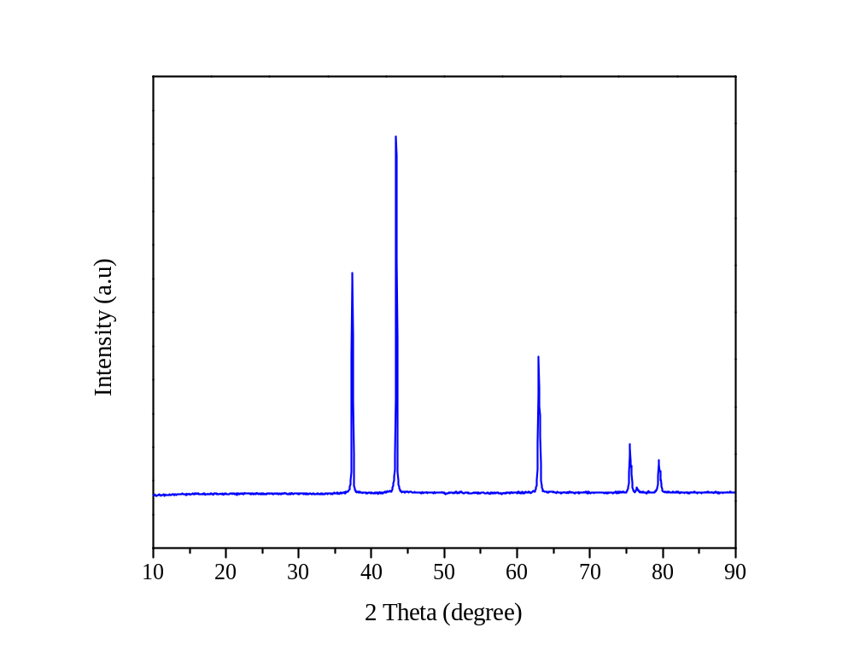

Figure 1. Powder XRD result of NiO sample.

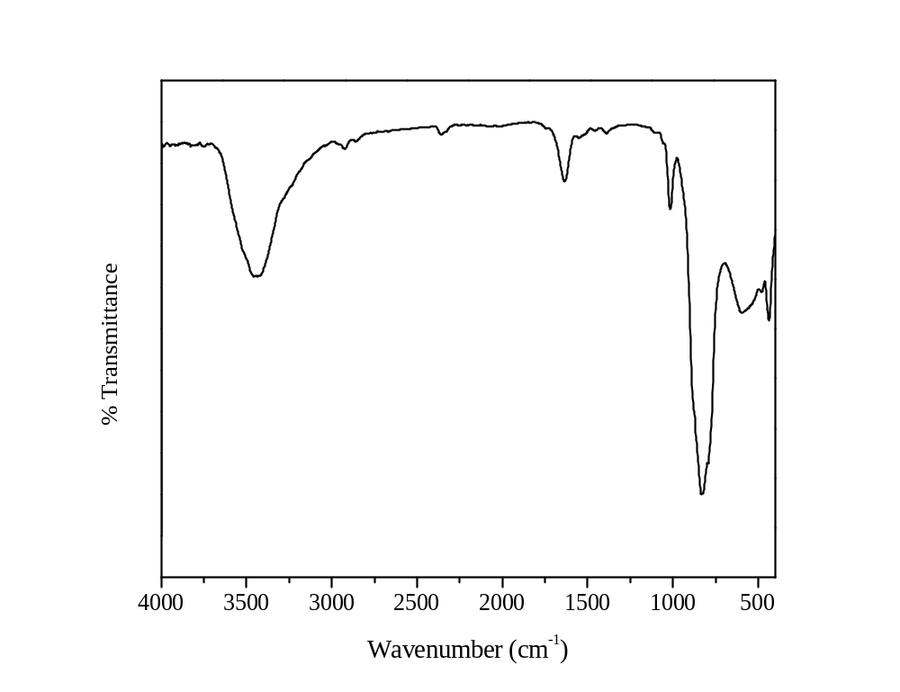

Figure 2. FT-IR spectra of NiO sample.

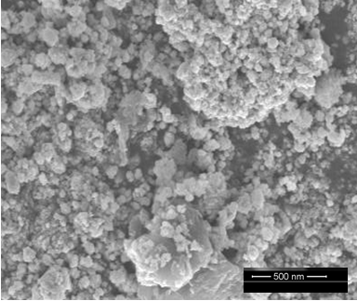

Figure 3. HR-SEM image of NiO sample.

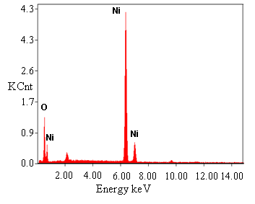

Figure 4. EDX spectrum of NiO sample.

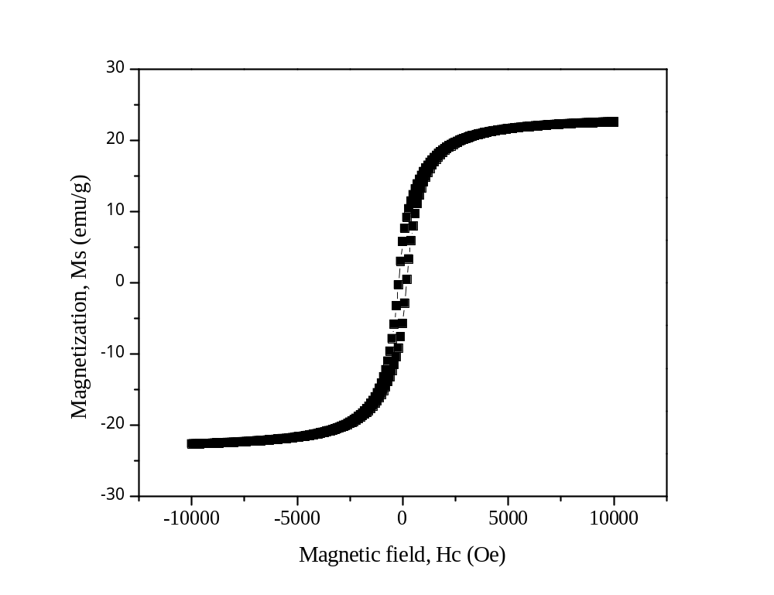

Figure 5. VSM hysterisis loop of NiO sample.

